
PREDICTIVE INTELLIGENCE FOR LANDSLIDE DISASTER PREVENTION: AN AI-POWERED EARLY WARNING SYSTEM USING HYBRID DATA SOURCES
Cohort Number: 17
Team Members and Roles

USN | Name | Role
1HK22AI063  1HK22EC051  1DT22IC003  1GC22CS068 | Hafeeza Tasneem  Hajira Shahanz A  Akshay S  Mohammed Umar Maniyar | Data Collection, Data Preprocessing and EDA
1HK22AI062  1GC22CS096  1ST22CS240  1ST22CS241  1EW22IS070 | Zeba Shine  Safdar Iqbal  Vasanth Kumar H R  Vibhashree R  Nakshatra S | ML Engineer
1GC23CS419  1RI22CS108  2AV22CS005  1MV22EC056  4AD22EC062  4VM22IS004 | Tasaduque Ullah  Sridhar Y Gowdar  Amruta Suresh Aralelimath  Harshith G K  Nayana M B  Benaka M | Front End and Back End

Cohort Leaders
USN | Name | Role
1HK22AI062  1GC22CS096  1MV22EC056  1DT22IC003 | Zeba Shine  Safdar Iqbal  Harshith G K  Akshay S Gowda | President  Vice President  Secretary  Deputy Secretary
Table of Contents
1. INTRODUCTION 5
2. PROBLEM STATEMENT 6
3. OBJECTIVES 6
4. DATASET DESCRIPTION 7
5. SYSTEM ARCHITECTURE 8
5.1 Presentation Layer (Frontend) 9
5.2 API Communication Layer 11
5.3 Backend Processing Layer 11
5.4 AI-Assisted Prediction Engine 12
5.5 External Data Integration Layer 13
5.7 Authentication and Security Layer 15
5.8 Alert and Notification Layer 16
6. APIs AND DATA FLOW 17
6.1 OpenWeatherMap API 17
6.2 NASA GIBS API 17
6.3 NASA EONET API 18
6.4 NASA LHASA Integration 19
6.5 Internal Data Flow 19
7. METHODOLOGY 20
7.1 Requirement Analysis 20
7.2 Dataset Study and Environmental Analysis 20
7.3 Frontend Development 21
7.4 Backend Development 22
7.5 API Integration 22
7.7 Authentication and Security 24
7.8 Alert Generation and Notification System 24
7.9 Testing and Validation 24
8. RISK PREDICTION LOGIC 25
8.1 Overview of the Prediction Engine 25
8.2 Risk Classification Categories 26
8.3 Environmental Parameter Analysis 26
8.4 NASA LHASA Integration 27
8.5 Temporal Prediction Logic 28
8.6 Spatial Prediction Logic 28
8.7 Dynamic Risk Computation 28
8.8 Alert Triggering Logic 29
9. IMPLEMENTATION 30
9.1 Frontend Implementation 30
9.2 Backend Implementation 31
9.3 Database Implementation 32
9.4 Authentication and Security Implementation 32
9.6 Alert and Notification System Implementation 33
9.7 System Testing 34
10. RESULTS AND OUTPUTS 34
10.1 Dashboard Visualization Output 35
10.2 Environmental Telemetry Analysis 35
10.3 Risk Prediction Results 35
10.4 NASA Satellite Imagery Integration 36
10.5 Environmental Event Tracking 36
10.6 Alert Generation Output 37
10.7 Authentication and Admin System Results 37
10.8 Overall System Performance 38
11. CHALLENGES FACED 38
11.1 Real-Time API Integration Challenges 39
11.2 Geospatial Data Handling 39
11.3 Environmental Risk Computation 39
11.4 Authentication and Security Implementation 40
11.5 Email Notification System 40
11.6 Frontend Responsiveness and Visualization 40
11.7 Team Coordination and Collaboration 41
11.8 Overall Learning Experience 41
12. CONCLUSION 41
13. FUTURE SCOPE 43
13.1 Deep Learning-Based Landslide Prediction 43
13.2 Real-Time IoT Sensor Integration 43
13.3 Mobile Application Development 44
13.4 Advanced GIS and 3D Terrain Visualization 44
13.5 Cloud Deployment and Scalability 44
13.6 Real-Time Government and Disaster Management Integration 45
13.7 Multi-Disaster Monitoring Support 45
13.8 Enhanced AI-Assisted Analytics 45
14. REFERENCES 45

1. INTRODUCTION
Natural disasters continue to pose significant threats to human populations and infrastructure across the world. Among these disasters, landslides are particularly dangerous because they occur suddenly and are heavily influenced by environmental conditions such as rainfall, terrain steepness, soil saturation, and geological instability. Regions with mountainous terrain and heavy rainfall are especially vulnerable to landslide events.
Traditional disaster monitoring systems often depend on delayed reporting, fragmented environmental analysis, and limited visualization capabilities. These limitations reduce the ability of authorities and communities to respond effectively during critical situations. With advancements in artificial intelligence, geospatial systems, satellite imaging, and real-time environmental APIs, it is now possible to develop intelligent systems capable of predicting and monitoring environmental hazards dynamically.
The project titled “Predictive Intelligence for Landslide Disaster Prevention: An AI-Powered Early Warning System using Hybrid Data Sources” aims to address these limitations by developing an integrated geospatial disaster monitoring platform. The system combines environmental telemetry, terrain-based risk analysis, satellite imagery services, and AI-assisted prediction logic to estimate landslide risk in real time.
The platform integrates multiple technologies including React and Tailwind CSS for interactive frontend visualization, FastAPI for backend processing, OpenWeatherMap APIs for meteorological data, and NASA APIs for satellite imagery and environmental event tracking. The system uses heuristic intelligence and telemetry-driven analytics to calculate dynamic landslide risk scores and generate automated alerts.
In addition to monitoring environmental conditions, the project also incorporates geospatial visualization through interactive maps, secure authentication systems, and administrative management modules. The inclusion of alert generation mechanisms further enhances disaster preparedness by providing timely warnings to users during high-risk conditions.
The project demonstrates the practical application of artificial intelligence, GIS systems, remote sensing concepts, and modern web technologies in solving real-world disaster management problems.

2. PROBLEM STATEMENT
Landslides are highly destructive natural hazards that frequently occur in mountainous and high-rainfall regions. The increasing effects of climate change, extreme rainfall events, deforestation, and unplanned urbanization have significantly increased the frequency and severity of landslides worldwide.
Existing landslide monitoring systems suffer from several limitations:
- Lack of real-time environmental analysis
- Delayed disaster warnings
- Limited integration of satellite and weather data
- Absence of centralized monitoring dashboards
- Poor visualization of hazard-prone regions
- Inefficient communication during emergencies
Most traditional systems rely on static geological surveys or manual monitoring approaches, which are insufficient for rapidly changing environmental conditions. Additionally, many systems fail to combine meteorological data, terrain intelligence, and satellite imagery into a single integrated platform.
There is therefore a need for an intelligent, real-time, and scalable disaster prevention system capable of analyzing environmental conditions dynamically and generating early warnings for landslide-prone areas.
The proposed system addresses these challenges by integrating hybrid environmental data sources, geospatial visualization, AI-assisted risk analysis, and automated alert mechanisms into a unified landslide early warning platform.

3. OBJECTIVES
The main objectives of the project are:
- To develop an intelligent landslide monitoring and early warning system
- To integrate real-time environmental data using OpenWeather APIs
- To incorporate NASA satellite imagery and environmental event services
- To analyze rainfall, humidity, and terrain conditions dynamically
- To implement AI-assisted heuristic risk prediction logic
- To provide interactive geospatial visualization using GIS mapping
- To generate automated alerts during high-risk conditions
- To develop secure user authentication and administrative modules
- To improve disaster preparedness and situational awareness

4. DATASET DESCRIPTION
The project incorporates concepts from the Landslide4Sense dataset, which is a remote sensing dataset designed for landslide detection using satellite imagery and terrain analysis.
The dataset contains Sentinel-2 satellite imagery combined with Digital Elevation Model (DEM) and slope information. Each image contains 14 channels, including spectral bands and terrain-related features. The image dimensions are 128 × 128 pixels and are stored in HDF5 format.
The dataset provides pixel-level annotations where each image is paired with a segmentation mask identifying landslide and non-landslide regions. These annotations are useful for semantic segmentation tasks in landslide analysis.
Terrain-related parameters such as slope and elevation are critical because landslides are strongly influenced by geographical steepness, rainfall accumulation, and soil instability.
The dataset is divided into training, validation, and testing subsets and is generally evaluated using the F1-score metric. The dataset supports applications such as:
- Landslide detection
- Disaster management
- Environmental monitoring
- Terrain analysis
- Geospatial intelligence
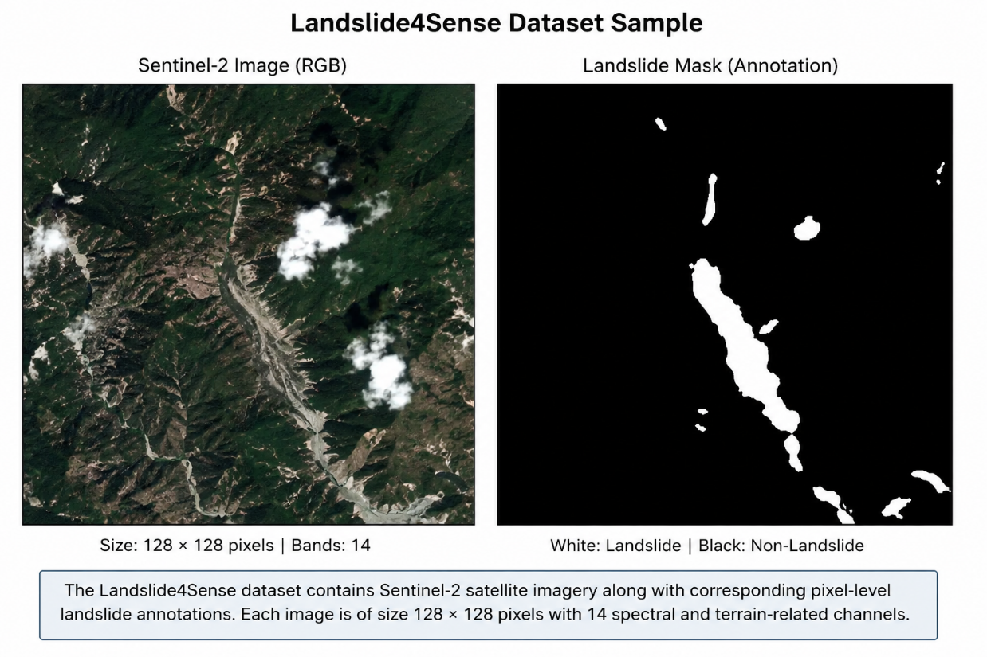
The dataset was studied to understand terrain characteristics and the role of environmental factors in landslide susceptibility prediction.
Figure 4.1: Sample Landslide4Sense satellite image and corresponding landslide segmentation mask

5. SYSTEM ARCHITECTURE
The proposed system follows a multi-layer full-stack architecture designed for real-time environmental monitoring, intelligent risk analysis, and automated disaster alert generation. The architecture integrates frontend visualization, backend processing, AI-assisted prediction logic, external environmental APIs, and secure database management into a unified platform.

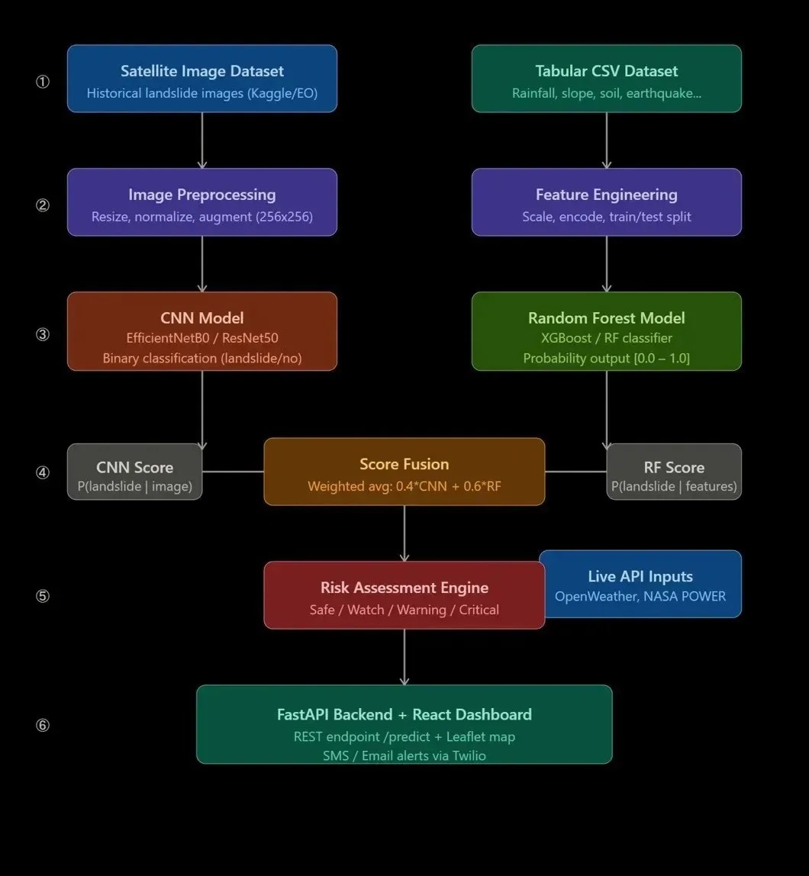
Figure 5.0: Hybrid AI-based landslide prediction and risk assessment workflow
The system architecture is divided into the following major layers:

5.1 Presentation Layer (Frontend)
The frontend of the system was developed using modern web technologies including React.js, Vite, Tailwind CSS, and React Leaflet. The frontend provides an interactive and visually responsive dashboard for monitoring environmental hazards and viewing landslide risk predictions.
The frontend layer is responsible for:
- User interaction and navigation
- Displaying hazard maps and geospatial visualizations
- Rendering telemetry data and analytics
- Displaying risk categories and alerts
- Managing user authentication interfaces
- Providing responsive dashboard visualization
The user interface follows a cyber-themed glassmorphism design with interactive animations and real-time visual updates.
Technologies Used
- React.js
- Vite
- Tailwind CSS
- React Leaflet
- Framer Motion
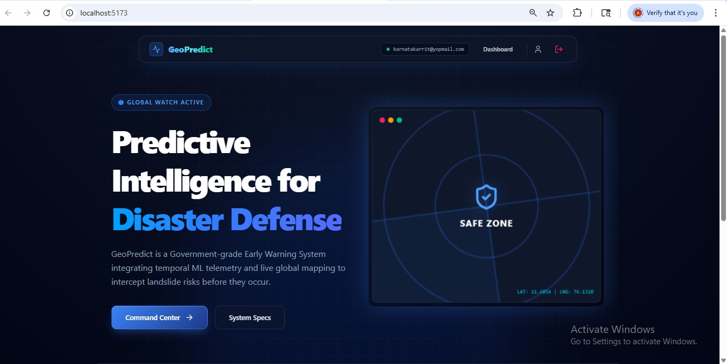
- Lucide React

Figure 5.1: GeoPredict landing dashboard displaying the interactive disaster monitoring interface
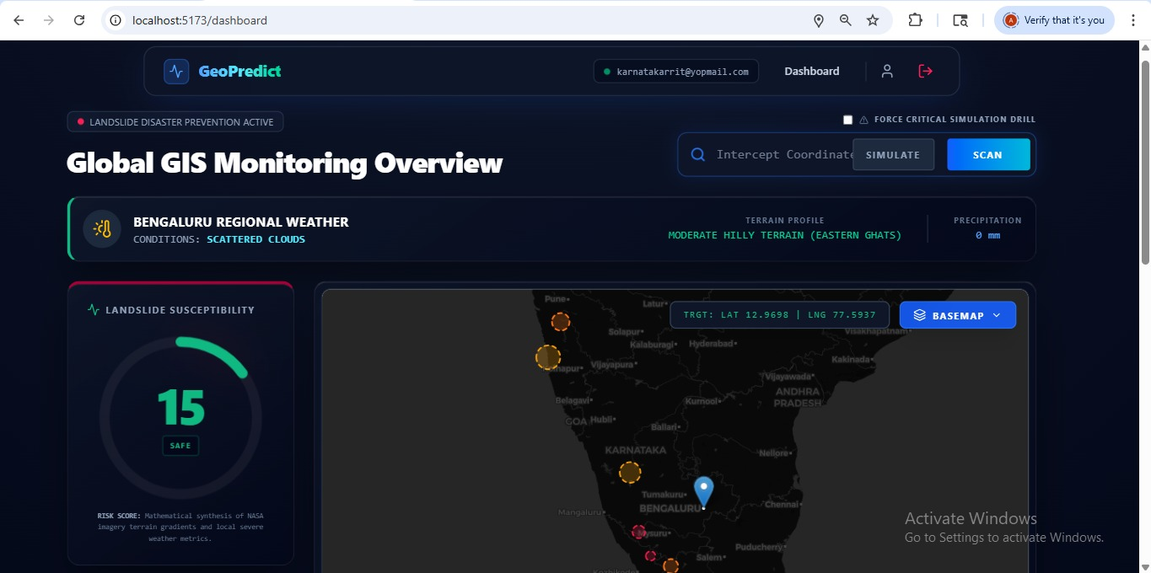
Figure 5.2: Geospatial monitoring dashboard with interactive map visualization

5.2 API Communication Layer
The frontend communicates with the backend using RESTful APIs through secure HTTP requests and JSON responses. This layer acts as the communication bridge between the visualization dashboard and backend intelligence engine.
The API communication layer is responsible for:
- Sending prediction requests
- Fetching environmental telemetry
- Retrieving satellite imagery
- Managing authentication sessions
- Receiving risk predictions and alerts

5.3 Backend Processing Layer
The backend of the system was implemented using FastAPI, a high-performance Python web framework designed for asynchronous processing and API development.
The backend layer handles:
- Request processing
- Environmental data analysis
- Risk computation
- API integrations
- Authentication and authorization
- Database management
- Alert generation
FastAPI was selected because of its asynchronous capabilities and efficient handling of external APIs such as NASA and OpenWeather services.
Backend Components
- FastAPI
- Uvicorn
- SQLAlchemy
- BackgroundTasks
- smtplib
- JWT Authentication

5.4 AI-Assisted Prediction Engine
The intelligent prediction engine is the core analytical component of the system. It computes landslide susceptibility using environmental telemetry and terrain heuristics.
The engine analyzes:
- Rainfall intensity
- Soil saturation
- Humidity
- Terrain classification
- Slope-based geofencing
Based on these parameters, the system dynamically calculates a risk score between 0 and 100.

Risk Categories
Risk Score | Category
0 – 29 | SAFE
30 – 49 | WATCH
50 – 74 | WARNING
75 – 100 | CRITICAL EVACUATION
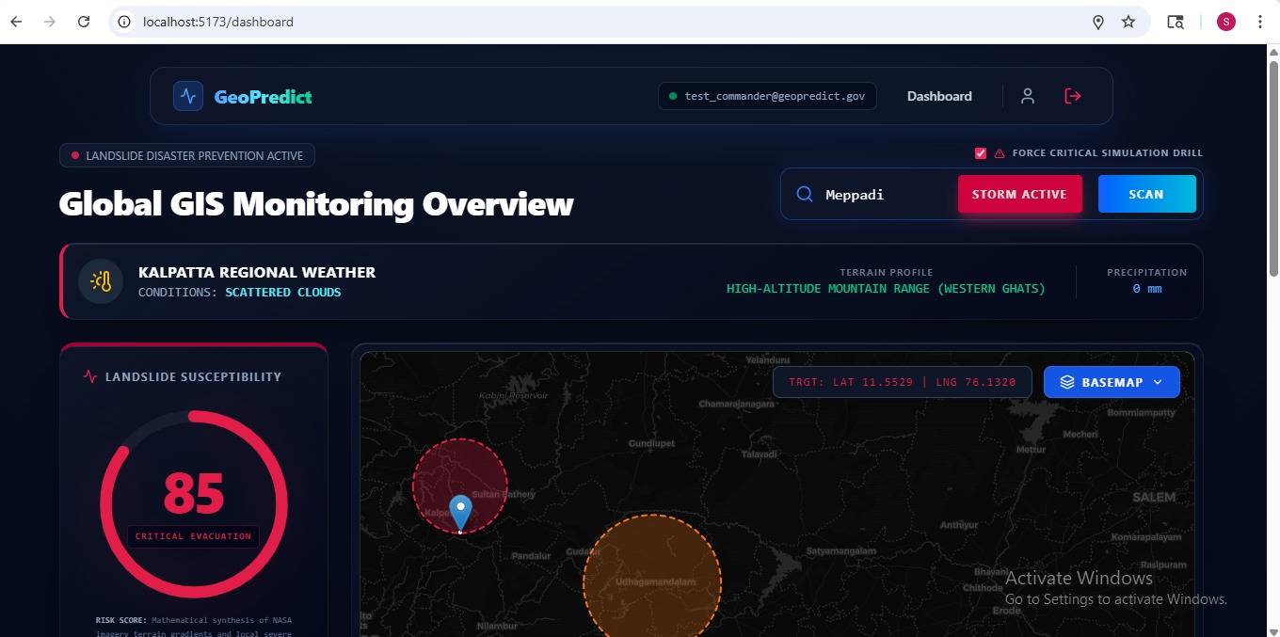
The prediction logic is implemented using heuristic intelligence and telemetry-driven analysis rather than a traditional deep learning production pipeline.

Figure 5.3: Dynamic landslide risk prediction generated using environmental telemetry

5.5 External Data Integration Layer
The system integrates multiple real-time environmental and satellite APIs to improve prediction reliability and situational awareness.
OpenWeatherMap API
Used for:
- Rainfall analysis
- Humidity analysis
- Weather condition monitoring
NASA APIs
NASA GIBS
Provides satellite imagery and visual environmental monitoring.
NASA EONET
Tracks ongoing natural disaster events such as floods, storms, and landslides.
NASA LHASA
Used for landslide susceptibility analysis and hazard assessment.
The integration of hybrid data sources significantly improves the intelligence and responsiveness of the system.
5.6 Database Layer
The system uses MySQL as the primary database management system along with SQLAlchemy ORM for object-relational mapping.
The database stores:
- User accounts
- Authentication data
- OTP verification records
- User profiles
- Notification preferences
Main Database Tables
- User
- Profile
- OTP
The database layer ensures secure storage and efficient retrieval of application data.

5.7 Authentication and Security Layer
The system implements a secure authentication framework using JWT-based authorization and bcrypt password hashing.
Security features include:
- Secure login and registration
- JWT token authentication
- OTP verification
- Role-based admin access
- Protected routes
- Password encryption
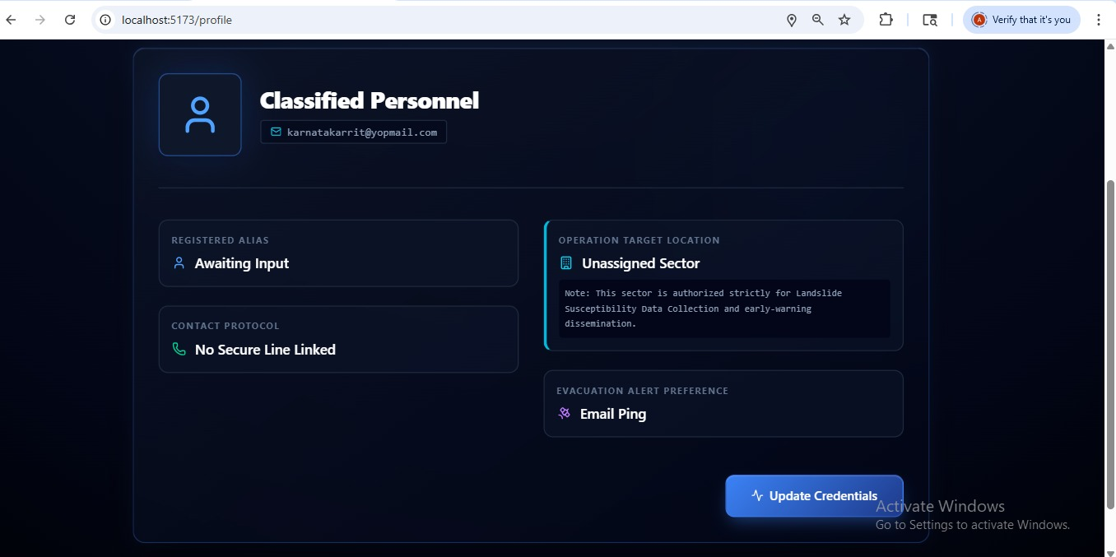
These mechanisms ensure secure access to the platform and prevent unauthorized usage.

Figure 5.4: Secure user authentication interface with login and registration functionality
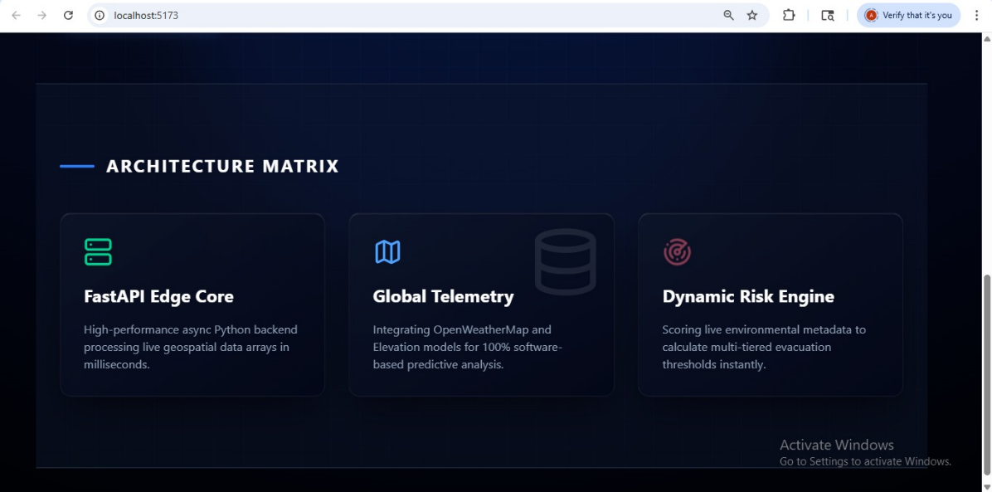
Figure 5.5: System architecture visualization of backend telemetry and risk engine modules

5.8 Alert and Notification Layer
The platform includes an automated emergency alert mechanism for notifying users during high-risk conditions.
When the risk score exceeds predefined thresholds:
- The frontend displays critical alerts
- The backend dispatches automated HTML-based warning emails
- Environmental telemetry is included in the alert message
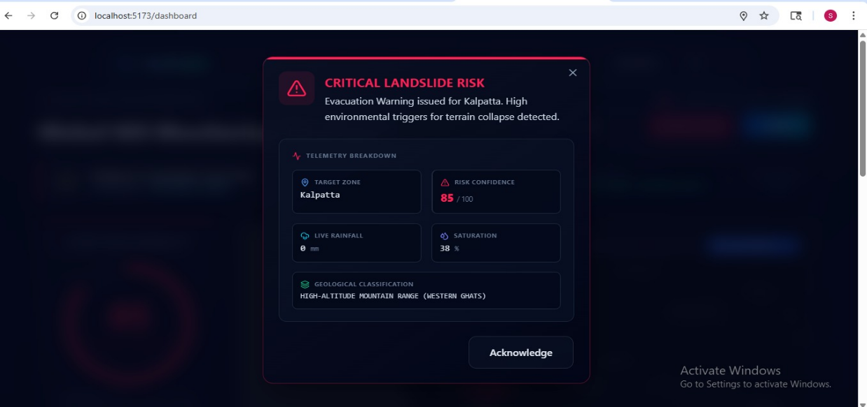
This layer improves disaster preparedness and emergency response efficiency.

Figure 5.6: Critical disaster alert generated during high-risk environmental conditions

6. APIs AND DATA FLOW
The system integrates multiple external APIs and internal processing modules to perform real-time landslide risk analysis. The APIs provide live environmental telemetry, satellite imagery, and natural disaster event information, which are processed by the backend intelligence engine.

6.1 OpenWeatherMap API
The OpenWeatherMap API is used as the primary meteorological data source for the system.
Purpose
To retrieve real-time weather conditions that influence landslide susceptibility.
Parameters Extracted
- Rainfall in the last one hour
- Humidity percentage
- Weather conditions
- Temperature data
Working Process
- User enters coordinates or city name
- Backend sends API request to OpenWeatherMap
- Environmental telemetry is retrieved
- Data is passed to the risk engine
The rainfall parameter acts as the most important dynamic trigger in the prediction system because excessive rainfall significantly destabilizes terrain structures.

6.2 NASA GIBS API
NASA Global Imagery Browse Services (GIBS) is used for satellite imagery retrieval and visualization.
Purpose
To provide real-time satellite imagery for environmental observation and visual confirmation of terrain conditions.
Features
- MODIS Terra True Color imagery
- Dynamic image rendering
- Geospatial visualization
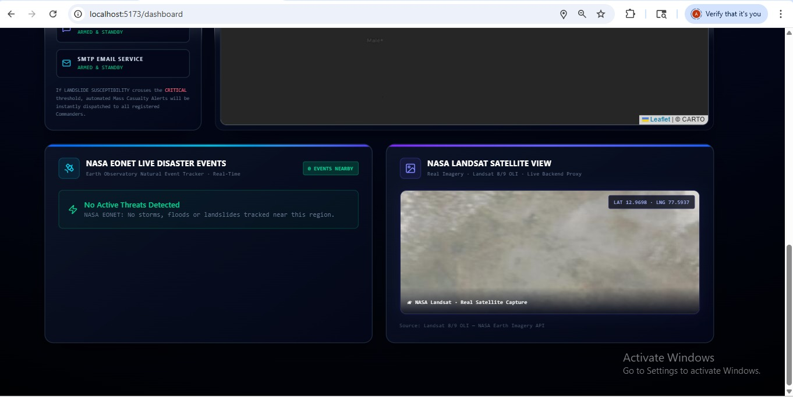
The backend acts as a proxy server to securely stream imagery to the frontend due to CORS restrictions.

Figure 6.1: Satellite imagery retrieved through NASA GIBS integration

6.3 NASA EONET API
NASA Earth Observatory Natural Event Tracker (EONET) is used for tracking active environmental disasters.
Purpose
To identify nearby environmental hazards relevant to landslide risk.
Events Tracked
- Severe storms
- Floods
- Landslides
- Volcanic events
The backend filters relevant environmental events within a specified geographic radius and displays them on the dashboard.

6.4 NASA LHASA Integration
NASA LHASA (Landslide Hazard Assessment for Situational Awareness) is integrated into the backend risk engine.
Purpose
To improve hazard assessment using terrain susceptibility and environmental telemetry.
Parameters Considered
- Terrain slope
- Rainfall accumulation
- Geographical susceptibility
- Surface saturation
LHASA logic improves the reliability of risk classification and enhances environmental intelligence.

6.5 Internal Data Flow
The internal workflow of the system is as follows:
- User enters location coordinates or city name
- Frontend sends request to FastAPI backend
- Backend fetches environmental telemetry from APIs
- Risk engine processes environmental conditions
- Dynamic risk score is calculated
- Risk category is assigned
- Results are returned to frontend dashboard
- Alerts are triggered if thresholds are exceeded
- Email notifications are dispatched to users
This workflow enables real-time disaster monitoring and early warning functionality.

7. METHODOLOGY
The methodology of the proposed system focuses on integrating real-time environmental telemetry, geospatial analysis, satellite imagery services, and AI-assisted heuristic intelligence into a unified disaster monitoring and early warning platform.
The system was developed using a modular full-stack architecture where frontend visualization, backend processing, environmental APIs, and risk prediction logic work together to analyze landslide susceptibility dynamically.
The methodology followed in the project consists of the following stages:

7.1 Requirement Analysis
The first phase involved identifying the major challenges associated with traditional landslide monitoring systems. The following requirements were identified:
- Real-time environmental monitoring
- Geospatial hazard visualization
- Dynamic risk prediction
- Integration of satellite and weather data
- Automated emergency alerts
- Secure user authentication
- Scalable system architecture
The analysis phase also included studying landslide risk factors such as rainfall intensity, terrain slope, humidity, and geological instability.

7.2 Dataset Study and Environmental Analysis
The Landslide4Sense dataset was studied to understand terrain-related landslide characteristics and remote sensing concepts.
The dataset includes:
- Sentinel-2 satellite imagery
- Digital Elevation Model (DEM)
- Slope-based terrain features
- Pixel-level landslide annotations
The study of the dataset helped in understanding:
- terrain susceptibility
- environmental influence on landslides
- geospatial analysis concepts
- semantic segmentation approaches
In addition to dataset analysis, live environmental telemetry was integrated using external APIs to improve real-time prediction capability.

7.3 Frontend Development
The frontend of the system was developed using React.js and Vite to create a responsive and interactive user interface.
Tailwind CSS was used for designing the dashboard layout and implementing the cyber-themed visual interface. React Leaflet was integrated for geospatial map visualization and hazard monitoring.
The frontend includes:
- Dashboard visualization
- Interactive GIS mapping
- User authentication pages
- Alert popups
- Satellite imagery display
- Environmental telemetry panels
The frontend communicates with the backend through RESTful APIs using JSON requests and responses.

7.4 Backend Development
The backend was implemented using FastAPI due to its asynchronous processing capabilities and efficient API handling.
The backend handles:
- environmental telemetry processing
- API integration
- risk prediction
- authentication
- database operations
- email dispatch
FastAPI routers were organized modularly for:
- authentication
- profile management
- admin management
- prediction APIs
The backend also acts as a proxy server for NASA imagery services.

7.5 API Integration
The system integrates multiple external APIs to retrieve live environmental and satellite data.
OpenWeatherMap API
Used for:
- rainfall monitoring
- humidity analysis
- weather condition retrieval
NASA APIs
NASA GIBS
Used for satellite imagery visualization.
NASA EONET
Used for tracking active natural disaster events.
NASA LHASA
Used for landslide susceptibility assessment.
These APIs provide real-time environmental intelligence required for dynamic hazard analysis.
7.6 AI-Assisted Risk Prediction
The core intelligence engine of the system computes landslide risk dynamically using heuristic analysis.
The following environmental parameters are analyzed:
- Rainfall intensity
- Humidity percentage
- Soil saturation
- Terrain classification
- Mountain geofencing
The system calculates a dynamic risk score between 0 and 100.
The prediction logic categorizes the risk as:
- SAFE
- WATCH
- WARNING
- CRITICAL EVACUATION
The heuristic-based approach enables rapid analysis without requiring computationally expensive deep learning inference in real-time environments.

7.7 Authentication and Security
The system implements secure authentication and authorization mechanisms using JWT tokens and bcrypt password hashing.
Security features include:
- user registration
- secure login
- OTP verification
- protected routes
- role-based access control
Admin users are provided additional privileges for managing users and monitoring platform activity.

7.8 Alert Generation and Notification System
The system includes an automated disaster alert mechanism that dispatches warning notifications during high-risk conditions.
When the calculated risk exceeds predefined thresholds:
- visual alerts are displayed on the dashboard
- emergency email notifications are generated
- telemetry data is attached to warning messages
The email system uses HTML-formatted templates for professional emergency dispatch notifications.

7.9 Testing and Validation
The developed system was executed and tested using different environmental conditions and location inputs.
Testing included:
- API response validation
- risk score generation
- authentication testing
- alert generation testing
- dashboard functionality verification
- satellite imagery retrieval
The system successfully generated dynamic risk classifications and visual hazard outputs based on real-time environmental telemetry
.

8. RISK PREDICTION LOGIC
The risk prediction engine is the core analytical component of the GeoPredict system. It is responsible for analyzing environmental telemetry, terrain characteristics, and satellite-based hazard indicators to estimate the probability of landslide occurrence in real time.
Unlike traditional static monitoring systems, the proposed system uses dynamic heuristic intelligence and environmental telemetry to continuously calculate risk levels based on changing conditions.
The prediction engine was implemented within the FastAPI backend and integrates live environmental data obtained from OpenWeatherMap and NASA APIs.

8.1 Overview of the Prediction Engine
The prediction system computes a dynamic landslide risk score ranging from 0 to 100. The score is generated using multiple environmental and geospatial parameters that influence terrain instability.
The prediction engine evaluates:
- Rainfall intensity
- Humidity percentage
- Soil saturation
- Terrain classification
- Geographical susceptibility
- Mountain geofencing
- Satellite-based hazard information
Based on the computed score, the system classifies environmental conditions into different warning levels.

8.2 Risk Classification Categories
The final risk score is categorized into four major warning levels:
Risk Score Range | Risk Category
0 – 29 | SAFE
30 – 49 | WATCH
50 – 74 | WARNING
75 – 100 | CRITICAL EVACUATION
These classifications help users and authorities understand the severity of environmental conditions and respond accordingly.

8.3 Environmental Parameter Analysis
Rainfall Analysis
Rainfall acts as the primary trigger for landslides because excessive precipitation destabilizes soil layers and increases surface load.
The system retrieves rainfall telemetry using the OpenWeatherMap API and analyzes:
- rainfall in the last one hour
- storm conditions
- precipitation intensity
Higher rainfall values significantly increase the risk score.
Humidity and Soil Saturation
Humidity is used as an indicator of environmental dampness and soil moisture accumulation.
When humidity exceeds critical thresholds:
- soil instability increases
- terrain saturation rises
- landslide probability becomes higher
The system increases the risk score dynamically based on humidity percentage.
Terrain Classification and Geofencing
Terrain characteristics are critical in determining landslide susceptibility.
The backend contains geofencing logic that identifies whether the selected coordinates belong to:
- Western Ghats
- Himalayan regions
- Eastern Ghats
- normal plains
Mountainous regions automatically increase baseline risk because steep slopes are more vulnerable to collapse during heavy rainfall.

8.4 NASA LHASA Integration
The system integrates NASA LHASA (Landslide Hazard Assessment for Situational Awareness) concepts for hazard assessment.
NASA LHASA improves the prediction engine by combining:
- rainfall telemetry
- terrain susceptibility
- geographical instability
- environmental conditions
The backend attempts to retrieve susceptibility information from NASA services and uses fallback heuristic analysis when API responses are unavailable.
This improves system reliability and ensures uninterrupted prediction functionality.

8.5 Temporal Prediction Logic
The temporal prediction API evaluates environmental telemetry dynamically over time.
The API processes:
- rainfall amount
- slope angle
- soil saturation
The system calculates:
- baseline risk
- environmental amplification
- terrain influence
The temporal model simulates intelligent hazard escalation during rapidly changing weather conditions.

8.6 Spatial Prediction Logic
The spatial prediction module simulates satellite-image-based landslide detection.
The system accepts image inputs and generates:
- simulated detections
- bounding boxes
- confidence scores
- landslide region analysis
The spatial component represents the integration of remote sensing concepts and AI-assisted environmental interpretation.

8.7 Dynamic Risk Computation
The final risk score is computed by combining:
- environmental telemetry
- terrain heuristics
- satellite-based indicators
- weather severity
- susceptibility modifiers
The prediction engine dynamically updates risk values in real time and continuously adapts to changing environmental conditions.
This allows the platform to:
- monitor hazard escalation
- identify high-risk terrain
- generate timely warnings
- improve situational awareness

8.8 Alert Triggering Logic
The alert mechanism is activated when the risk score exceeds predefined thresholds.
Warning Thresholds
- WARNING → Risk Score ≥ 50
- CRITICAL EVACUATION → Risk Score ≥ 75
When thresholds are crossed:
- the frontend displays visual emergency alerts
- the backend generates HTML-formatted email notifications
- telemetry details are included in warning messages
This automated workflow improves disaster preparedness and rapid emergency communication.

9. IMPLEMENTATION
The implementation phase focused on integrating frontend visualization, backend processing, API communication, database management, and intelligent risk prediction into a unified disaster monitoring platform.
The project was implemented using a modular full-stack development approach where different components were developed independently and integrated into a centralized system.

9.1 Frontend Implementation
The frontend of the system was developed using React.js and Vite to create a fast and responsive user interface.
Tailwind CSS was used for styling and implementing the cyber-themed visual dashboard. React Leaflet was integrated for geospatial map visualization and terrain interaction.
Frontend Features
- Interactive dashboard
- GIS-based map visualization
- Responsive user interface
- Hazard analytics display
- Alert modals
- User authentication pages
- Satellite imagery display
The frontend communicates with the FastAPI backend through REST APIs and dynamically updates telemetry information without requiring page reloads.

9.2 Backend Implementation
The backend was implemented using FastAPI because of its asynchronous processing capability and efficient API routing mechanisms.
The backend handles:
- telemetry processing
- prediction logic
- NASA/OpenWeather API integration
- authentication
- database communication
- email dispatch
The backend architecture was organized into modular routers for:
- authentication
- profile management
- admin management
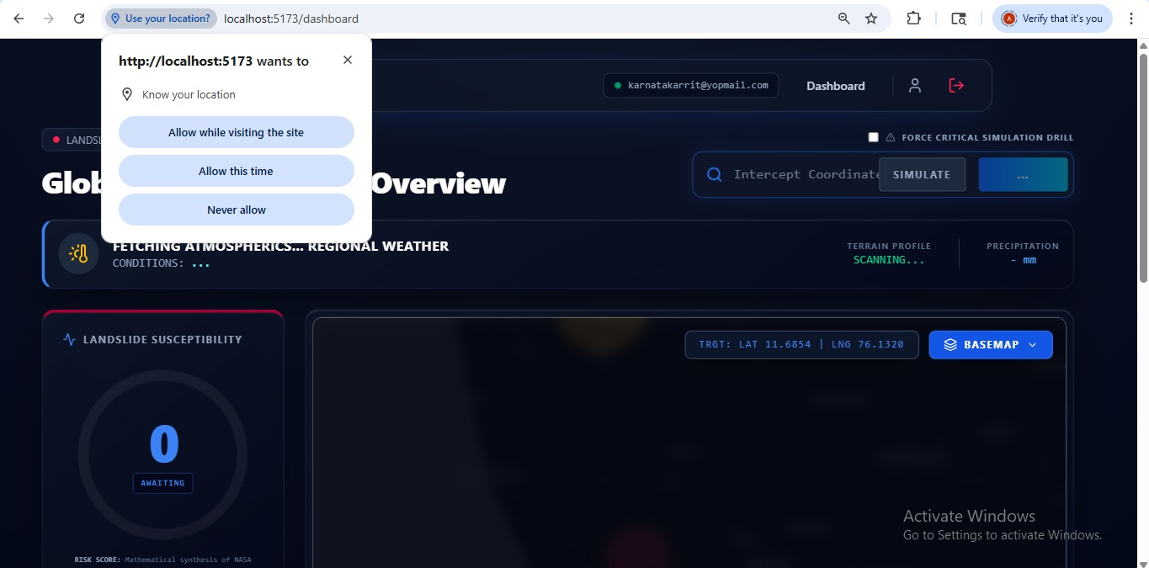
- prediction APIs

Figure 9.1: FastAPI backend API documentation interface

9.3 Database Implementation
The system uses MySQL as the primary database and SQLAlchemy ORM for database interaction.
The database stores:
- user accounts
- profile information
- OTP records
- notification preferences
Database Tables
- User
- Profile
- OTP
The database layer ensures secure and efficient data storage for authentication and user management.

9.4 Authentication and Security Implementation
Secure authentication mechanisms were implemented using:
- JWT tokens
- bcrypt password hashing
- protected API routes
- role-based access control
The system includes:
- user registration
- secure login
- OTP verification
- admin privileges
- session management
Protected routes prevent unauthorized access to prediction and administrative modules.
9.5 API Integration Implementation
The backend integrates multiple external APIs to retrieve real-time environmental and geospatial data.
OpenWeatherMap API
Used for:
- rainfall telemetry
- humidity analysis
- weather conditions
NASA APIs
- NASA GIBS for satellite imagery
- NASA EONET for disaster event tracking
- NASA LHASA for landslide susceptibility analysis
The backend processes API responses and forwards relevant data to the frontend dashboard.

9.6 Alert and Notification System Implementation
The platform includes an automated alert generation mechanism for high-risk environmental conditions.
When the calculated risk exceeds predefined thresholds:
- the dashboard displays warning alerts
- emergency notifications are generated
- HTML email alerts are dispatched
The email notification system includes:
- risk score
- terrain information
- rainfall telemetry
- location details
This improves emergency awareness and disaster preparedness.

9.7 System Testing
The system was tested using different environmental conditions and location inputs.
Testing included:
- API validation
- telemetry analysis
- risk score verification
- authentication testing
- dashboard functionality testing
- alert generation testing
The platform successfully generated dynamic landslide risk predictions and visual hazard outputs based on real-time telemetry data.

10. RESULTS AND OUTPUTS
The developed GeoPredict system successfully integrates environmental telemetry, geospatial visualization, satellite imagery services, and AI-assisted risk analysis into a unified disaster monitoring platform. The system was tested using different geographical locations and varying environmental conditions to evaluate the effectiveness of the prediction engine and monitoring workflow.
The platform demonstrated the ability to dynamically analyze environmental conditions, generate hazard classifications, retrieve satellite imagery, and dispatch emergency alerts during high-risk scenarios.

10.1 Dashboard Visualization Output
The frontend dashboard successfully displayed:
- interactive geospatial maps
- telemetry information
- environmental analytics
- hazard visualization
- dynamic monitoring panels
The React-based dashboard provided a responsive user interface with smooth interaction and real-time updates.
The integration of Leaflet maps enabled users to visualize hazard-prone regions and monitor terrain conditions interactively.

10.2 Environmental Telemetry Analysis
The system successfully retrieved and analyzed environmental telemetry using the OpenWeatherMap API.
The telemetry module processed:
- rainfall intensity
- humidity percentage
- weather conditions
- location-based environmental data
The environmental data was dynamically incorporated into the prediction engine to compute landslide risk scores.
The platform demonstrated reliable real-time telemetry retrieval and environmental condition monitoring.

10.3 Risk Prediction Results
The AI-assisted prediction engine successfully generated dynamic risk scores based on environmental and terrain conditions.
The system classified locations into:
- SAFE
- WATCH
- WARNING
- CRITICAL EVACUATION
The prediction engine effectively simulated hazard escalation during adverse environmental conditions such as:
- heavy rainfall
- high humidity
- mountainous terrain conditions
The dynamic risk computation improved situational awareness and supported early warning generation.

10.4 NASA Satellite Imagery Integration
The integration of NASA GIBS services enabled the system to retrieve satellite imagery for selected locations.
The platform successfully displayed:
- satellite terrain visualization
- environmental imagery
- remote sensing data
The NASA imagery integration enhanced visual understanding of terrain conditions and environmental monitoring.

10.5 Environmental Event Tracking
NASA EONET integration enabled the platform to retrieve active environmental disaster events.
The system successfully identified:
- floods
- storms
- landslides
- severe environmental conditions
The event tracking system improved disaster awareness and provided additional environmental intelligence for hazard monitoring.

10.6 Alert Generation Output
The automated alert generation mechanism successfully triggered warnings during high-risk environmental conditions.
When the calculated risk exceeded threshold values:
- visual emergency alerts were displayed on the dashboard
- HTML-based email notifications were dispatched
- telemetry details were attached to warning messages
The emergency notification workflow improved rapid communication and disaster preparedness.

10.7 Authentication and Admin System Results
The authentication framework successfully implemented:
- secure user registration
- login functionality
- JWT token authorization
- protected routes
- role-based admin access
The admin dashboard successfully supported:
- user monitoring
- account management
- profile management
- administrative controls
The security framework ensured controlled access to system resources and prediction services.

10.8 Overall System Performance
The system successfully integrated:
- frontend visualization
- backend processing
- environmental APIs
- geospatial monitoring
- authentication mechanisms
- automated alerts
The modular architecture improved scalability, maintainability, and responsiveness.
The platform demonstrated the practical application of:
- AI-assisted analytics
- geospatial intelligence
- environmental telemetry
- disaster management systems
for real-world landslide monitoring and early warning applications.

11. CHALLENGES FACED
During the development of the GeoPredict system, several technical and implementation-related challenges were encountered. These challenges provided valuable practical learning experiences in full-stack development, API integration, geospatial analysis, and disaster intelligence systems.

11.1 Real-Time API Integration Challenges
Integrating multiple real-time APIs such as OpenWeatherMap and NASA services introduced challenges related to:
- network latency
- API response delays
- timeout handling
- inconsistent response formats
Certain NASA services occasionally experienced delayed responses or temporary unavailability, requiring fallback heuristic mechanisms within the backend.

11.2 Geospatial Data Handling
Handling geospatial data and terrain visualization was a complex task due to:
- coordinate management
- terrain classification
- hazard visualization
- map rendering
Integrating Leaflet maps and dynamically plotting environmental data required careful frontend-backend synchronization.

11.3 Environmental Risk Computation
Designing the heuristic-based risk engine required balancing multiple environmental parameters such as:
- rainfall
- humidity
- terrain elevation
- slope influence
Determining appropriate threshold values for hazard classification required repeated testing and adjustment.

11.4 Authentication and Security Implementation
Implementing secure authentication mechanisms introduced challenges such as:
- JWT token handling
- protected route management
- secure password hashing
- session validation
Ensuring secure communication between frontend and backend components required proper authorization handling.

11.5 Email Notification System
The automated email dispatch mechanism required:
- SMTP configuration
- HTML email template design
- background task handling
- alert synchronization
Managing asynchronous alert dispatch without affecting dashboard responsiveness was an important implementation challenge.

11.6 Frontend Responsiveness and Visualization
Designing a visually interactive dashboard while maintaining responsiveness and performance required optimization of:
- animations
- component rendering
- map updates
- telemetry refresh mechanisms
The integration of cyber-themed UI components and real-time visual updates required extensive frontend refinement.

11.7 Team Coordination and Collaboration
Since the project was developed as a collaborative team effort, effective coordination between:
- dataset analysis team
- ML team
- frontend/backend development team
- documentation team
was essential for successful project integration.
Regular discussions, workflow synchronization, and task distribution were necessary to ensure smooth development progress.

11.8 Overall Learning Experience
Despite the challenges, the project provided valuable exposure to:
- full-stack system development
- geospatial technologies
- API integration
- AI-assisted analytics
- disaster intelligence systems
- collaborative software development
The challenges helped improve both technical and problem-solving skills while demonstrating the complexity of real-world environmental monitoring systems.

12. CONCLUSION
The project titled “Predictive Intelligence for Landslide Disaster Prevention: An AI-Powered Early Warning System using Hybrid Data Sources” successfully demonstrates the integration of artificial intelligence concepts, geospatial intelligence, environmental telemetry, and full-stack web technologies into a unified disaster monitoring platform.
The system effectively combines real-time environmental data, satellite imagery services, terrain-based analysis, and heuristic risk prediction logic to estimate landslide susceptibility dynamically. By integrating APIs such as OpenWeatherMap and NASA services, the platform provides enhanced situational awareness and environmental monitoring capabilities.
The developed platform successfully implemented:
- interactive geospatial visualization
- dynamic landslide risk prediction
- secure authentication mechanisms
- automated emergency alert generation
- satellite imagery integration
- disaster event tracking
The AI-assisted prediction engine dynamically analyzed rainfall intensity, humidity, terrain classification, and environmental conditions to generate real-time risk scores and warning categories.
The project also demonstrated the practical application of:
- GIS systems
- remote sensing concepts
- full-stack engineering
- environmental analytics
- intelligent disaster monitoring
The modular architecture of the system improves scalability, maintainability, and future extensibility for real-world disaster management applications.
Overall, the project provided significant practical exposure to:
- frontend and backend integration
- geospatial technologies
- API-driven architectures
- environmental monitoring systems
- collaborative software development
The developed platform can serve as a foundation for future intelligent disaster prevention systems and contributes toward improving disaster preparedness and early warning mechanisms in landslide-prone regions.

13. FUTURE SCOPE
The GeoPredict system provides a strong foundation for future enhancements in intelligent disaster prevention and environmental monitoring systems. Several improvements and advanced integrations can further increase the accuracy, scalability, and real-world applicability of the platform.
Future enhancements may include:

13.1 Deep Learning-Based Landslide Prediction
Future versions of the system can integrate advanced deep learning models such as:
- Convolutional Neural Networks (CNNs)
- U-Net segmentation models
- Transformer-based remote sensing architectures
These models can improve automated terrain analysis and satellite-image-based landslide detection.

13.2 Real-Time IoT Sensor Integration
The platform can be extended to integrate IoT-based environmental sensors for:
- soil moisture monitoring
- ground vibration analysis
- rainfall sensing
- terrain displacement detection
This would improve real-time environmental telemetry and increase prediction reliability.

13.3 Mobile Application Development
A dedicated mobile application can be developed to:
- provide instant alerts
- support offline emergency notifications
- enable location-based hazard monitoring
- improve accessibility during emergencies

13.4 Advanced GIS and 3D Terrain Visualization
Future systems can include:
- advanced GIS layers
- 3D terrain rendering
- elevation heatmaps
- real-time satellite overlays
These features would improve environmental visualization and terrain interpretation.

13.5 Cloud Deployment and Scalability
The platform can be deployed using cloud technologies such as:
- AWS
- Microsoft Azure
- Google Cloud Platform
Cloud deployment would improve:
- scalability
- availability
- distributed monitoring
- disaster resilience

13.6 Real-Time Government and Disaster Management Integration
Future integration with:
- disaster management authorities
- emergency response systems
- public alert networks
could improve large-scale emergency communication and coordinated disaster response.

13.7 Multi-Disaster Monitoring Support
The platform can be extended to monitor additional environmental hazards such as:
- floods
- earthquakes
- forest fires
- cyclones
- severe storms
This would transform the system into a broader intelligent environmental hazard monitoring platform.

13.8 Enhanced AI-Assisted Analytics
Future versions may include:
- predictive trend analysis
- anomaly detection
- historical environmental analysis
- adaptive learning systems
These features would improve the intelligence and automation capability of the platform.

14. REFERNCES

- Landslide4Sense Dataset – Kaggle
https://www.kaggle.com/datasets/tekbahadurkshetri/landslide4sense
- OpenWeatherMap API Documentation
https://openweathermap.org/api
- NASA GIBS (Global Imagery Browse Services)
https://gibs.earthdata.nasa.gov
- NASA EONET (Earth Observatory Natural Event Tracker)
https://eonet.gsfc.nasa.gov
- NASA LHASA – Landslide Hazard Assessment for Situational Awareness https://gpm.nasa.gov/applications/lhasa
- FastAPI Official Documentation
https://fastapi.tiangolo.com
- React Official Documentation
https://react.dev
- Tailwind CSS Documentation
https://tailwindcss.com
- Leaflet Documentation
https://leafletjs.com
- SQLAlchemy Documentation
https://www.sqlalchemy.org
- JWT Authentication Documentation
https://jwt.io
- Python Official Documentation
https://www.python.org
- Framer Motion Documentation
https://www.framer.com/motion/
- Sentinel-2 Remote Sensing Documentation
https://sentinel.esa.int
- Research Papers and Online Resources Related to Landslide Prediction, GIS Systems, and Environmental Monitoring.

